Date access: 2020-03-09

<http://wjw.beijing.gov.cn/wjwh/ztzl/xxgzbd/gzbdyqtb/202001/t20200130_1621744.html>

From 9 am to 2 pm on January 27, 8 new cases of pneumonia infected with new coronavirus were reported in this city, and 1 died.

Date: 2020-01-27 Source: Beijing Municipal Commission of Health

        From 9 am to 2 pm on January 27, eight new cases of pneumonia infected with the new coronavirus were added to the city, one of whom was a close contact with a previously confirmed case, and has been sent to a municipal designated medical institution for treatment. One case of death was a male, 50 years old. He went to Wuhan on January 8 and developed fever after returning to Beijing on the 15th. He went to the hospital on the 21st and was diagnosed on the 22nd. His condition worsened today and he died of respiratory failure due to respiratory failure.

As of 20:00 on January 27, the city has accumulated 80 confirmed cases, of which 2 were discharged, 63 were stable, 12 were critically ill, 2 were critically ill, and 1 died. 2 cases in Dongcheng District, 7 cases in Xicheng District, 17 cases in Chaoyang District, 17 cases in Haidian District, 4 cases in Fengtai District, 2 cases in Shijingshan District, 7 cases in Tongzhou District, 1 case in Shunyi District, 5 cases in Daxing District, and 7 cases in Changping District. There were 11 cases of foreigners coming to Beijing.

**1月27日9时至20时，本市新增8例新型冠状病毒感染的肺炎病例，死亡1例**

日期：2020-01-27 来源：北京市卫生健康委‍

        1月27日9时至20时，本市新增8例新型冠状病毒感染的肺炎病例，其中1例为此前确诊病例的密切接触者，已送至市级定点医疗机构进行救治。死亡1例，男，50岁，1月8日前往武汉，15日返京后出现发热症状，21日到医院就诊，22日确诊，今日病情恶化，因呼吸功能衰竭，经抢救无效死亡。

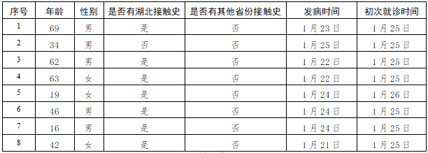

        截至1月27日20时，本市累计确诊病例80例，其中出院2例，病情平稳63例，重症12例，危重症2例，死亡1例。东城区2例、西城区7例、朝阳区17例、海淀区17例、丰台区4例、石景山区2例、通州区7例、顺义区1例、大兴区5例、昌平区7例，外地来京人员11例。